EMPLOYEE ONBOARDING

Built on ServiceNow

Project Guide: P. SRILEKHA MAM
Submitted to: P. SRILEKHA MAM

Team Name: FlowForge

TEAM MEMBERS

Name | Roll Number
M. Deepthi | 23MH1A42A4
M. Vamsi | 23P31A0539
P. Laharika | 23A91A0554
Ch. Nikitha | 23P3A12D0
A. Sai | 23A91A1269
D. Rohit | 23P31A4466

ABSTRACT
The Smart Campus / Enterprise Workflow Management System is a ServiceNow-based application developed to automate and simplify organizational activities digitally. The project replaces manual paperwork, phone calls, spreadsheets, and traditional tracking systems with a centralized automated platform.
The system helps organizations manage requests, onboarding processes, issue tracking, workflows, approvals, notifications, reports, dashboards, and user communication efficiently.
This project provides:
- Faster request handling
- Better communication between departments
- Centralized data management
- Workflow automation
- Real-time monitoring
- Improved transparency
- Better user experience
The application is useful for:
- Colleges
- Universities
- Companies
- IT Departments
- HR Departments
- Administrative Teams
- Support Teams
The project was developed using ServiceNow platform capabilities such as:
- App Engine Studio
- Tables and Forms
- ACLs
- Flow Designer
- Workflows
- Notifications
- Reports and Dashboards
- Service Portal
- Virtual Agent
- Knowledge Management

INTRODUCTION
Digital transformation has become essential for organizations to manage operations efficiently. Traditional manual systems consume more time, create communication gaps, increase paperwork, and make tracking difficult.
To overcome these problems, we developed a Smart Campus / Enterprise Workflow Management System using ServiceNow.
The project automates different organizational operations such as:
- User onboarding
- Issue management
- Service requests
- Task assignment
- Approval workflows
- Notifications
- Monitoring and reporting
The platform provides a user-friendly interface where users can submit requests, track statuses, receive notifications, and access knowledge articles.
Administrators can monitor all activities using dashboards and reports.

PROBLEM STATEMENT
Many organizations still depend on manual processes for managing employee requests, issue tracking, onboarding, approvals, and communication.
Problems in manual systems include:
- Delayed response times
- Poor tracking
- Miscommunication
- Excessive paperwork
- Lack of centralized management
- Difficulty in monitoring tasks
- Limited transparency
- Difficulty generating reports
To solve these problems, an automated workflow-based system is required.

PROPOSED SOLUTION
The proposed solution is a ServiceNow-based workflow automation platform that digitizes organizational operations.
The system provides:
- Automated workflows
- Request management
- Issue tracking
- User and role management
- SLA tracking
- Real-time notifications
- Dashboards and reports
- Knowledge articles
- Virtual Agent support
- Service Portal access
The application improves efficiency, reduces manual work, and provides better monitoring and communication.

OBJECTIVES OF THE PROJECT
The major objectives of the project are:
- To digitize manual organizational processes
- To reduce paperwork and manual effort
- To automate workflows and approvals
- To improve communication between departments
- To provide centralized request management
- To track issues and requests effectively
- To generate reports and dashboards for monitoring
- To improve response and resolution times
- To provide user-friendly portal access
- To enhance transparency and accountability

WHY WE CHOOSE SERVICENOW
ServiceNow is a powerful cloud-based workflow automation platform widely used in real-time industries.
We selected ServiceNow because:
- It supports low-code/no-code development
- It provides workflow automation
- It supports role-based access control
- It offers professional UI and dashboards
- It enables quick development
- It provides secure data handling
- It supports integrations and scalability

Advantages of ServiceNow
- Easy to use
- Cloud-based platform
- Workflow automation
- Real-time notifications
- Secure access management
- Professional dashboards
- Scalable architecture
- User-friendly service portal

PROJECT SCOPE

In Scope
The project covers:
- User management
- Role management
- Group management
- Employee/Student onboarding
- Issue tracking
- Daily request management
- Workflow automation
- SLA management
- Notifications
- Reports and dashboards
- Knowledge management
- Virtual Agent
- Service Portal

Out of Scope
The project currently does not include:
- Mobile application
- AI-based analytics
- Multi-language support
- Third-party cloud integrations
- Voice assistant support

MODULES IN THE PROJECT

8.1 User Management
This module manages all users accessing the system.

Features
- User creation
- User authentication
- User profile management
- Department assignment

Examples of Users
- Employee
- Student
- HR
- IT Support
- Admin
- Manager

8.2 Role Management
Roles define permissions and responsibilities.

Roles Used
- Admin
- HR User
- IT Support
- Employee
- Manager

Purpose
- Restrict unauthorized access
- Provide secure operations
- Manage module-level permissions

8.3 Group Management
Groups help organize users into teams.

Groups Created
- HR Team
- IT Team
- Support Team
- Management Team

Benefits
- Easier task assignment
- Better workflow management
- Shared responsibilities

8.4 Onboarding Module
This module manages onboarding requests for new employees or students.

Features
- Request submission
- Approval workflow
- Task generation
- Status tracking

Example Workflow
- User submits onboarding request
- HR verifies details
- IT assigns system access
- Manager approves request
- Request gets completed

8.5 Issue Tracking Module
This module helps users report and manage issues.

Features
- Issue submission
- Priority assignment
- Status tracking
- Task assignment
- Resolution tracking

Example Issues
- Login problems
- System errors
- Network issues
- Portal access issues

8.6 Daily Request / Service Module
This module manages daily service requests.

Features
- Request creation
- Tracking
- Assignment
- Notifications

8.7 Workflow Automation
Workflows automate organizational processes.

Features
- Automatic approvals
- Task assignment
- Status updates
- Notifications

Benefits
- Reduces manual work
- Improves efficiency
- Faster processing

8.8 Notifications
Notifications automatically inform users about updates.

Notification Methods
- Email notifications
- System notifications

Examples
- Request submitted
- Approval completed
- Task assigned
- Issue resolved

8.9 SLA Management
SLA (Service Level Agreement) tracks service response and resolution times.

Examples
- Issues resolved within 24 hours
- Onboarding completed within 2 days

Benefits
- Better performance tracking
- Improved accountability
- Faster service delivery

8.10 Reports and Dashboards
Reports and dashboards provide analytics and monitoring.

Types of Reports
- Pie charts
- Bar charts
- Line charts
- List reports

Dashboard Features
- Performance indicators
- Statistics
- Graphs and charts
- Real-time monitoring

8.11 Knowledge Management
Knowledge articles help users solve common problems.

Examples
- Password reset guide
- Login troubleshooting
- Portal usage instructions
- FAQs

Benefits
- Reduces repeated support requests
- Improves user experience

8.12 Virtual Agent
Virtual Agent acts as a chatbot.

Features
- Answers user questions
- Guides users through requests
- Shares knowledge articles
- Provides quick support

Benefits
- 24/7 support
- Faster responses
- Reduced support workload

8.13 Service Portal
Service Portal provides a modern front-end interface for users.

Features
- User login
- Request submission
- Issue tracking
- Knowledge article access
- Status monitoring

Technologies Used
- HTML
- CSS
- JavaScript

SYSTEM ARCHITECTURE
The system architecture consists of multiple ServiceNow components working together.
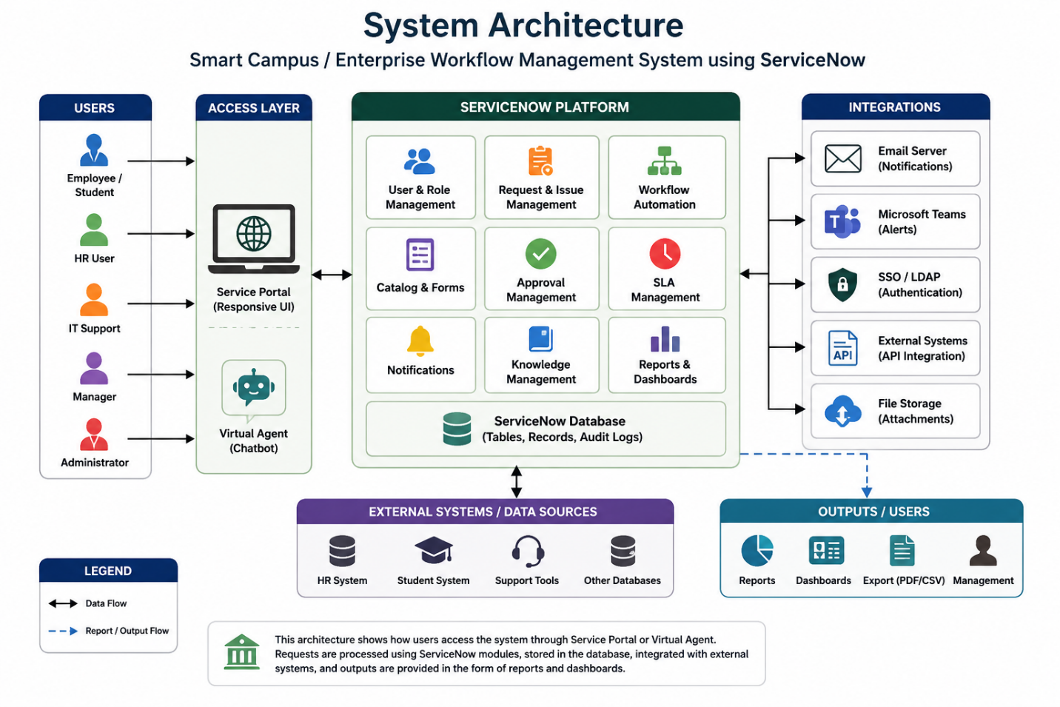

Main Components
- Users
- Service Portal
- ServiceNow Application
- Tables and Forms
- Workflows and Flow Designer
- Business Rules
- Notifications
- Reports and Dashboards
- Database Storage

Working Flow
- User logs into portal
- User submits request or issue
- Workflow gets triggered
- Tasks assigned automatically
- Notifications sent
- SLA timer starts
- Team resolves request
- Status updated
- User receives completion notification
- Record stored for future tracking

TECHNOLOGIES USED

Main Platform
- ServiceNow

Additional Technologies
- HTML
- CSS
- JavaScript

ServiceNow Components Used
- App Engine Studio
- Tables
- Forms
- ACLs
- Workflows
- Flow Designer
- Notifications
- Reports
- Dashboards
- Virtual Agent
- Service Portal
- Knowledge Base

STEP-BY-STEP PROJECT DEVELOPMENT

STEP 1: Creating the Application
The project started by creating a custom application in App Engine Studio.

Application Includes
- Application name
- Scope
- Modules
- Navigation menu

Purpose
Acts as the central container for the project.

STEP 2: Creating Users
Users were created to access the system.

User Information
- Name
- Email
- Username
- Password
- Department

STEP 3: Creating Roles
Roles were created to control access permissions.

Examples
- admin
- hr_user
- it_support
- employee
- manager

STEP 4: Creating Groups
Groups were created for better task management.

Examples
- HR Team
- IT Team
- Support Team
- Management Team

STEP 5: Creating Tables
Custom tables were created to store records.

Tables Created
- Onboarding Table
- Issue Tracking Table
- Daily Request Table
- Service Request Table

STEP 6: Creating Fields
Fields were added inside tables.

Example Fields
- Request Number
- Name
- Department
- Priority
- Status
- Description
- Assigned To
- Approval Status

STEP 7: Designing Forms
Forms were customized for better user interaction.

Customizations
- Form sections
- Mandatory fields
- Choice fields
- Layout adjustments

STEP 8: Configuring Lists
List layouts were configured for record management.

Features
- Sorting
- Searching
- Filtering
- Column customization

STEP 9: Configuring ACLs
ACLs were created to secure data.

Controls
- Read access
- Create access
- Update access
- Delete access

STEP 10: Creating Workflows
Workflows automated business processes.

Workflow Activities
- Approvals
- Notifications
- Task creation
- Status updates

STEP 11: Workflow Tasks
Workflow tasks divide work between teams.

Example Tasks
- Verify documents
- Create user account
- Assign laptop
- Approve request

STEP 12: SLA Configuration
SLAs were configured to track service timelines.

Example
- Resolve issue within 24 hours
- Complete onboarding within 2 days

STEP 13: Business Rules
Business Rules automate backend logic.

Examples
- Auto assignment
- Status updates
- Priority changes
- Automatic notifications

STEP 14: Notifications
Notifications keep users updated automatically.

Examples
- Request created
- Task assigned
- Approval completed
- Request resolved

STEP 15: Reports
Reports were created for data analysis.

Examples
- Total issues
- Pending requests
- Resolved tickets
- Department-wise reports

STEP 16: Dashboards
Dashboards display multiple reports together.

Features
- Graphs
- Statistics
- KPIs
- Real-time monitoring

STEP 17: Knowledge Management
Knowledge articles were created for user support.

Examples
- FAQs
- Troubleshooting steps
- Usage guides

STEP 18: Virtual Agent
Virtual Agent chatbot was configured.

Features
- Quick support
- Guided conversations
- Knowledge article sharing

STEP 19: Service Portal
The Service Portal was customized for users.

Features
- Forms
- Login page
- Request tracking
- Knowledge articles

STEP 20: Testing
Testing was performed to verify all functionalities.

Testing Types
- Workflow testing
- ACL testing
- Notification testing
- SLA testing
- Portal testing

STEP 21: Final Deployment
After testing, the application was finalized and deployed.

Final Activities
- Workflow activation
- Role verification
- Dashboard publishing
- Portal readiness

DATABASE DESIGN

Main Tables Used
Table Name | Purpose
Onboarding Table | Stores onboarding requests
Issue Tracking Table | Stores issue records
Request Table | Stores service requests
User Table | Stores user details
Task Table | Stores workflow tasks

SECURITY IMPLEMENTATION
Security was implemented using ACLs and role-based access.

Security Features
- Role-based permissions
- Restricted record access
- Secure login system
- Controlled update permissions
- Group-based assignment

TESTING AND VALIDATION
The project was tested thoroughly.

Test Cases
Test Case | Expected Result
User login | Successful login
Request submission | Record created
Workflow execution | Tasks generated
Notifications | Email sent
SLA tracking | Timer starts
Dashboard loading | Reports displayed

BENEFITS OF THE PROJECT
The project provides several advantages.

Major Benefits
- Reduces manual work
- Saves time
- Improves efficiency
- Better communication
- Faster issue resolution
- Centralized management
- Real-time monitoring
- Better user experience
- Improved transparency

CHALLENGES FACED
During development, several challenges were encountered.

Challenges
- Understanding workflows
- ACL configuration
- Role assignment
- SLA setup
- Notification configuration
- Workflow testing
- Portal customization

Solutions
- Step-by-step testing
- Team collaboration
- ServiceNow documentation
- Continuous practice

TEAM CONTRIBUTIONS

Team Member Responsibilities

User and Form Management
- User creation
- Role assignment
- Group creation
- Tables and forms

Workflow and Automation
- Workflows
- Flow Designer
- Business Rules
- Approvals

Knowledge Management
- Knowledge articles
- FAQs

Virtual Agent
- Chatbot configuration
- Guided conversations

Reports and Dashboards
- Report generation
- Dashboard creation
- Analytics

Service Portal
- Front-end customization
- Portal interface design

FUTURE ENHANCEMENTS
Future improvements can include:
- AI-based issue prediction
- Mobile application integration
- Advanced analytics
- Multi-language support
- Voice assistant integration
- Third-party integrations
- AI-powered automation

CONCLUSION
The Smart Campus / Enterprise Workflow Management System successfully automates organizational processes using ServiceNow.
The system provides:
- Workflow automation
- User and request management
- Issue tracking
- Real-time monitoring
- Reports and dashboards
- Notifications and communication
- Knowledge management
- Portal access
The project demonstrates practical implementation of:
- IT Service Management
- Workflow automation
- Process optimization
- Secure application development
- Centralized management systems
Overall, the project improves organizational efficiency, reduces manual work, and provides a professional digital management solution suitable for colleges, companies, and enterprise environments.

REFERENCES
- ServiceNow Official Documentation
- ServiceNow Developer Portal
- App Engine Studio Documentation
- Flow Designer Documentation
- Service Portal Documentation
- Knowledge Base Articles
- ServiceNow Community Resources

APPENDICES

Appendix A – Screenshots
- Application Dashboard
- Forms and Tables
- Workflow Diagrams
- Reports and Dashboards
- Service Portal Pages
- Virtual Agent Screens

Appendix B – Sample Notifications
- Request Submission Email
- Approval Notification
- Task Assignment Notification
- Issue Resolution Notification

Appendix C – Sample Reports
- Pending Requests Report
- Resolved Issues Report
- SLA Performance Report
- Department-wise Analytics

